
AWARDS

2021
CATHAOIRLEACH’S

INFORMATION & TIPS FOR APPLICANTS

CATHAOIRLEACH’S AWARDS
2021

CLOSING DATE: Friday, September 17th 2021

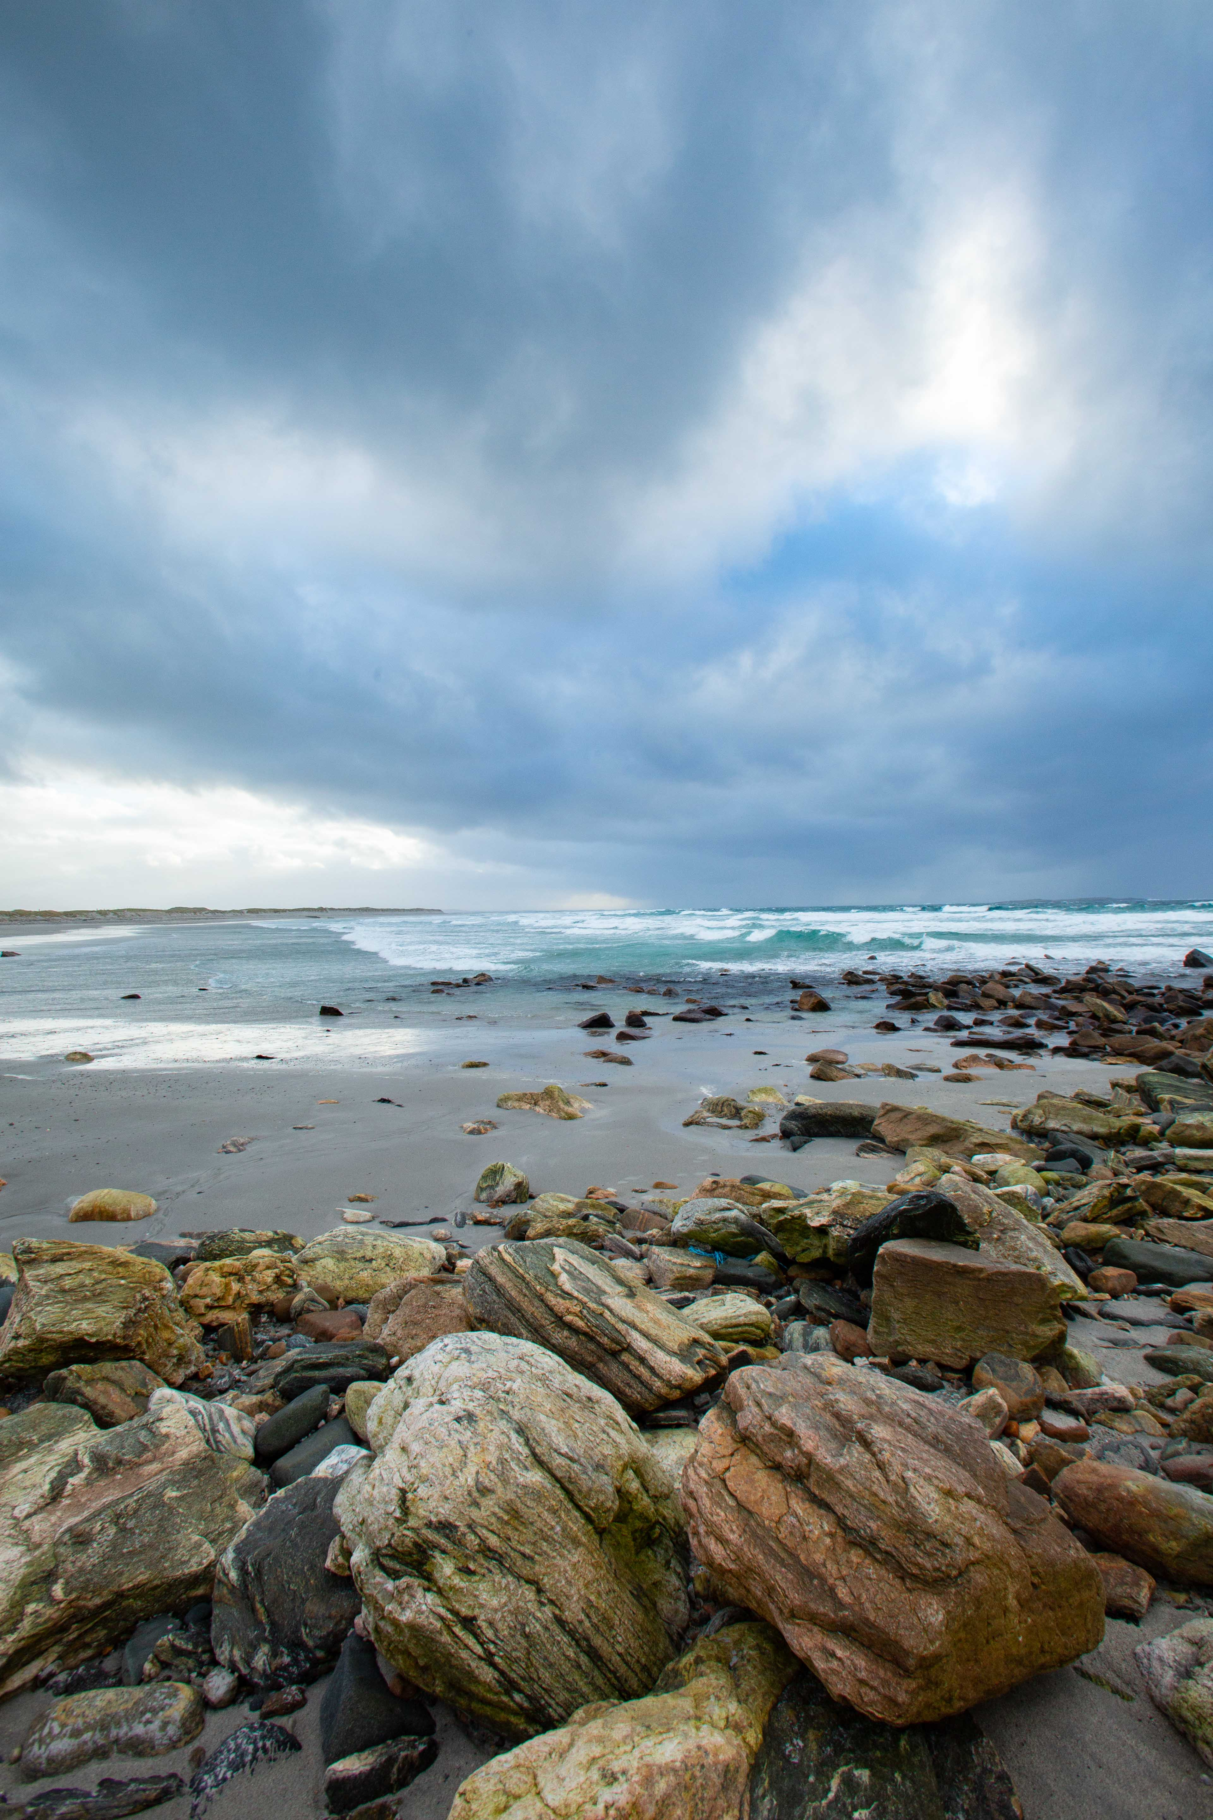

Community and voluntary activism is thriving in Mayo. It is both timely and vital that the services of the many community volunteer groups that work among us, and the valuable impact that work has on the quality of life of the citizens of County Mayo, is acknowledged publicly.
In recognition of this, Mayo County Council has decided to launch the first Cathaoirleach’s Awards in County Mayo.

What are the Cathaoirleach’s Awards?
The Cathaoirleach’s Awards honour and celebrate the many groups that work quietly behind the scenes to make our communities stronger, more vibrant and caring, often inspiring and motivating others to become actively involved in their communities.
Unsung heroes are to be found in every town, village, street and road in County Mayo. Of all ages and from all backgrounds, while working across diverse areas of interest, they all share one important characteristic; they give freely and generously of their time to make life better for their communities.
The public nomination process is now open. We invite you nominate those whom you would like to be recognised for the work they do.
The Categories are:
- Mayo Publication Award
- Contribution to Local Heritage Award
- Contribution to Community Life Awards
- Community Tourism Award
- Environmental Awards
- Contribution to the Arts in Mayo Award
- Contribution to the Preservation and Promotion of the Irish Language Awards
- Contribution to Diaspora Wellbeing/Engagement Award
- Cathaoirleach’s Recognition Award
full descriptions & category criteria are at the end of this information section

WHAT PRIZES ARE AWARDED?
All winners will be presented with a specially commissioned trophy hand crafted in Mayo.
Winners will also receive a monetary prize to use for their community work.

HOW DO I NOMINATE?
- There is one Nomination Form for all categories.
- Indicate which category you are making the nomination for at the top of the Nomination Form. An individual or group can be nominated under one category ONLY.
- Read the Nomination Form carefully. Page 1 is information regarding the group or person being nominated for an award and information regarding the person or group making the nomination.
- You may submit up to 4 hi-resolution photographs and 1 short video clip in support of your nomination.
- The closing date for the receipt of nomination forms is Friday, September 17th, 2021. Late applications will not be accepted.
- Applications may be submitted by email to communications@mayococo.ie or posted to the Communications Department, Mayo County Council, Áras an Chontae, Castlebar, Co Mayo, F23 WF90 to arrive not later than Friday, September 17th, 2021.

JUDGING/SHORTLISTING
All applications will be considered by a panel consisting of local authority staff and invited external experts.

A maximum of 13 Awards will be made, in the detailed categories below, at an event to take place in November 2021.

ARE THERE ANY CONDITIONS?
There are a few simple conditions:
- The winners of the 2021 Cathaoirleach’s Awards will be announced at a presentation
event to take place in November 2021
(subject to public health restrictions). The shortlisted nominees must be present on the night when the winner will be announced. Short listed nominees will be notified in advance.
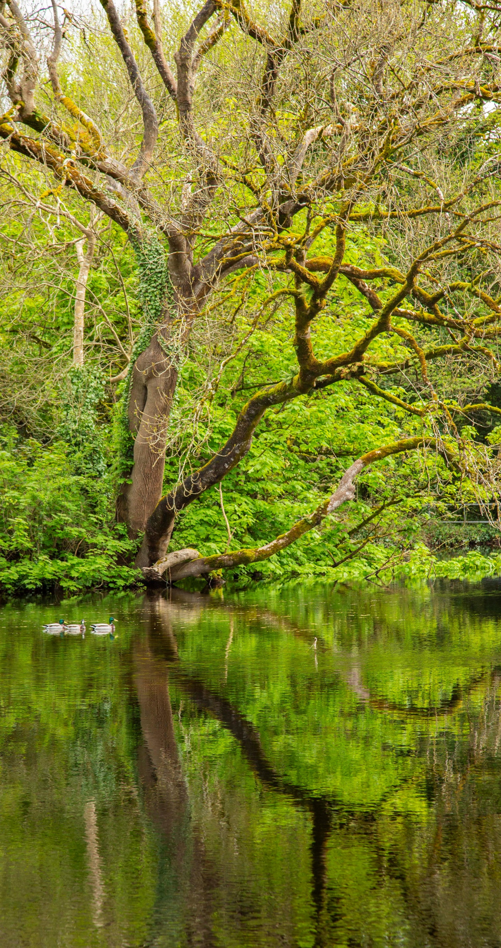
- Except for the Diaspora Award, nominees should normally live or carry out the activities for which they are being nominated within County Mayo.
- Groups may nominate themselves.
- When nominating, please ensure that the nominee had been notified.
- The work of all nominees must be on a not-for-profit or voluntary basis.
- Nominations will only be considered on the official Nomination Form, which must be signed and received by Friday, September 17th, 2021.
- The Data Protection Declaration on Page 5 of the Nomination Form must be completed.
- Elected Members or Staff of Mayo County Council are not eligible for nomination.
- Canvassing will disqualify.

ANY QUESTIONS? PLEASE CONTACT:

Communications Department
Mayo County Council
Áras an Chontae
Castlebar
Co Mayo F23 WF90

Email: communications@mayococo.ie
Telephone: 094 906 4000

Mayo Publication Award
(individual and Group Nominees Accepted)
This Award is for the best book on any aspect of life in Mayo. Entries may include local heritage and history, biography and autobiography, folklore and traditions, natural history, sport, parish annuals and any other aspect of life in the county. Publications from individuals, organisations and communities are accepted. Fiction, poetry and drama entries are not eligible.

Entries may be in Irish or in English / Is féidir iontrálacha a bheith i mBéarla nó i nGaeilge.

Entries must have been published between the 1st May 2020 and 1st May 2021 and two copies of nominated publication must be submitted to Mayo County Council for consideration.

Contribution to Local Heritage
(Group Nominees Only)
This Award recognises the contribution by groups to the conservation, management, protection or promotion of Mayo’s natural, built or cultural heritage.

The Award recognises:
- fresh approaches and initiatives that link heritage to communities, promoting active engagement with heritage and its appreciation by the public.
- the application of good heritage practice in managing sites, collections or objects.
- efforts/activities to ensure the survival of a heritage feature or structure.
- contribution to heritage knowledge through research or data collection.

Publications will not be considered for this award category.

Contribution to Community Life
(2 Awards)
Community Partnership Project Award
(Group Nominees Only, see ‘Tips for Applicants’ for further application advice)
This Award recognises community groups that show initiative, leadership and involvement in projects and activities that embody the spirit of genuine partnership and benefit the overall community.

Community Social Inclusion Project Award
(Group Nominees Only, see ‘Tips for Applicants’ for further application advice)
Social inclusion is about involving everyone within communities and this Award recognises those groups working to strengthen local communities, increase participation and promote social inclusion through their organisation, its activities and events.

Community Tourism Award
(Group Nominees Only, see ‘Tips for Applicants’ for further application advice)
The Community Tourism Award seeks to recognise the efforts of voluntary groups or social enterprises in contributing to the development of outstanding experiences for visitors to County Mayo.

The award will recognise any of the following:
- Initiatives that contribute to outstanding visitor experiences or extend the Céad Mίle Fáilte in our towns or rural areas.
- Collaborative initiatives between different visitor destinations in the County.
- Efforts that support a balanced calendar of annual events/activities.
- New or innovative attractions, activities or festivals.
- Collaboration with tourism and hospitality providers to ensure a high-quality integrated visitor service.

Environmental Awards
(2 Awards)
Young Environmentalist of the Year
(Individual Nominees Only, See ‘Tips for Applicants’ for further application advice)
(with public vote element to selection)

Environmental Community Group of the Year
(Not open for public nomination. Shortlist of Nominees will be selected internally)
(selected from Category winners of the National Tidy Towns Competition.
Contribution to the Arts in Mayo
(Group Nominees Only, see ‘Tips for Applicants’ for further application advice)
This category recognises the work that local voluntary groups do to encourage and promote the Arts in their community, including groups:
- that take every opportunity to promote the Arts in their community.
- who have been involved in activities and initiatives that stimulate public interest in the Arts.
- who have been involved in activities and initiatives that promote knowledge, appreciation and practice of the Arts.
- who have been involved in activities and initiatives that assist in improving standards in the Arts.

ÉACHT AR SON CHAOMHNÚ AGUS CHUR CHUN CINN NA GAEILGE
(2 GHRADAM)

(Is féidir daoine aonair agus grúpaí a ainmniú - féach 'Tips for Applicants' i gcomhair tuilleadh comhairle)
Tugann na gradaim seo aitheantas do Ghrupaí Deonacha agus do dhaoine aonair a thapaíonn gach deis an Ghaeilge a chur chun cinn ina gcuid pobal, ina measc:
- Grupaí deonacha, daoine aonair, tionscadail agus tograí scoile, féilte agus imeachtaí Gaeilge a chuireann an Ghaeilge chun cinn agus a mhéadaíonn úsáid na teanga ina gcuid pobal.
- Imeachtaí, idir chinn mhóra agus chinn bheaga, a spreagann daoine chun an Ghaeilge a labhairt – ó ghlantosaitheoirí go foghlaimeoirí ardleibhéil agus cainteoirí líofa a m'fhéidir nach mbeadh deis acu an Ghaeilge a úsáid ar bhonn laethúil.
- Daoine / Grúpaí a chuireann feasacht agus tuiscint ar an nGaeilge chomh maith le húsáid na teanga chun cinn ina gcuid pobal.

Bronnfar Gradaim ar Leith ar Ghrúpaí /Dhaoine Aonair:
- atá lonnaithe sa Ghaeltacht
- atá lonnaithe taobh amuigh den Ghaeltacht.

Contribution to THE PRESERVATION AND PROMOTION OF THE Irish Language (2 Awards)
(Individual and Group Nominees Accepted, see ‘Tips for Applicants’ for further application advice)
These awards recognise Voluntary Groups and Individuals that take every opportunity to promote the Irish Language in their community, including:

- Voluntary Groups, Individuals, Schools projects and initiatives, events/festivals ‘as Gaeilge’ that promote and increase the use of the Irish Language amongst their community.
- Organising events be they big or small that encourage people to speak the Irish Language from total beginners to advanced learners and fluent speakers that may not have the opportunity to use Irish on a daily basis.
- Promote knowledge, appreciation and use of the Irish Language in their community.

Separate Awards will be made to Groups
/Individuals:
- based in the Gaeltacht,
- based outside the defined Gaeltacht.

Contribution to Diaspora Wellbeing/Engagement
(individual and Group Nominees Accepted)
In general, this Award will recognise an overseas group or individual who has contributed to furthering the cause and wellbeing of Mayo people or causes overseas. The nominees for this Award would be specifically sought from Mayo Associations but any person or group can nominate.

Cathaoirleach’s Recognition Award
(Not open for public nomination. Shortlisting of Nominees is at the Cathaoirleach’s discretion)
This Award will recognise outstanding contributions to the ideals and spirit of Mayo – at home or overseas (Sustainability, Inclusiveness, Wellbeing, Pride in our County).

This award will allow Mayo County Council to acknowledge groups who do not fall within any of the categories outlined above.

contribution to community life awards

Community Partnership Project Award
This Award recognises community groups that show initiative, leadership, and involvement in projects and activities that embody the spirit of genuine partnership and benefit the overall community.

Only groups are eligible to apply

Include the following detail in your application:

The Nominated Group
- Must be a member of the Public Participation Network to be eligible for an Award. To apply for membership, visit https://mayoppn.ie/join-mayo-ppn
- Include some details on the membership of the group – set out how it represents the community.
- How long is the group in existence?
- How many members in the group?
- What is the group working to achieve – why was it set up?
- Is it open to new members?
- Does the group work with any other groups/organisations/agencies to achieve its goals?
- What values does the group hold?

Community
- Provide a brief profile of the community the group represents, i.e. the area’s population/demographic, whether rural /urban etc.
- How does the group actively involve members of the community to participate in community-based activities?
- What initiatives has the group run that has encouraged greater involvement from the Community?
- How has the group’s activities
impacted on the area?
- What important positive impact(s) has the group made to the community and how has it made a positive difference?

Past & Future Projects
- Provide specific examples of projects the group has been involved in
- Provide examples of what the group has achieved – through use of grant applications, local fundraising resulting in a project / activity.
- What projects are the group currently working on or plan to do?
- How did the group respond to Covid- 19, e.g. shopping delivery, online classes, outdoor activities?
- Provide documentation to support your application including photos

Community Social Inclusion Project Award
Social inclusion is about involving everyone within communities and this Award recognises those groups working to strengthen local communities, increase participation and promote social inclusion through their organisation, its activities and events.

Only groups are eligible to apply

Include the following detail in your application:

The Nominated Group
- Must be a member of the Public Participation Network to be eligible for an Award. To apply for membership, visit https://mayoppn.ie/join-mayo-ppn
- Include some details on the membership of the group – set out how it represents the community.
- How long is the group in existence?
- How many members in the group?
- What is the group working to achieve – why was it set up?
- Is it open to new members?
- Does the group work with any other groups/organisations/agencies to achieve its goals?

Community
- Provide a brief profile of the community the group represents, i.e. the area’s population/demographic, rural/urban etc.
- What need in this community did the group work to address?
- What important positive impact(s) has the group made to the community and how has it made a positive difference?

Past & Future Projects
- Provide specific examples of projects /activities/events the group has been involved in.
- Provide examples of what the group has achieved – through use of grant applications, local fundraising resulting in a project / activity / events.
- What projects/activities are the group currently working on or plan to do?
- Did the group become involved in a community response during Covid- 19?
- How does the work the group does strengthen networks/relationship with all members of the community?
- What projects has the group carried out to promote social inclusion?

COMMUNITY TOURISM AWARD
The Community Tourism Award seeks to recognise the efforts of voluntary groups or social enterprises in contributing to the development of outstanding experiences for visitors to County Mayo.
The Community Tourism Award will recognise any of the following:
- Initiatives that contribute to outstanding Visitor experiences or extend the Céad Mίle Fáilte in our towns or rural areas. This could include town or village ambassadors, enhanced visitor orientation services, new tourism product offerings etc.
- Collaborative initiatives between different visitor destinations in the county including cross selling initiatives, county wide product development, marketing and promotion.
- A Balanced calendar of annual events /activities which should have a particular focus on events held in the
off and/or shoulder seasons.
- Collaboration with tourism and hospitality providers to ensure a high-quality integrated visitor service. Collaborative initiatives could include cross selling, bundling of products for ease of use, enhanced experiences and value for money.

young environmentalist of the year award
This Award recognizes young people between the ages of 12 and 25 that show initiative, leadership, and involvement in projects and activities that have led to greater protection and awareness of the importance of care for the environment including positive action on climate change.

This award aims to empower young people to become engaged citizens in their community, and to build awareness of environmental issues by promoting local actions that help the environment.

Groups, schools, and individuals are eligible to nominate a young person who is a resident of Mayo for this award. Include the following detail in your application:

Name, age and community of young person being nominated.
Outline how the young person has shown leadership, initiative and involvement by highlighting the following:
- Projects that they have been involved in with their community or in their school to help promote environmental protection and climate action.
- Detail how they have shown leadership among their peers and in their community to promote environmental protection and climate action.
- Describe how they have positively engaged with their community on environment issues such as work with Tidy Towns groups or other local voluntary groups.

The young person can be nominated for work across one or more environmental themes including biodiversity, waste, litter, climate action, water, energy and sustainable development goals.

CONTRIBUTION TO THE ARTS IN MAYO AWARD
This category recognises the work that local voluntary groups have done to encourage and promote the Arts in their community.
Only groups are eligible to apply
Nominations can be submitted by:
- members of an Arts group or
- a member of the public can nominate an Arts group

Please consider the following before making a nomination:
- When nominating a group, please ensure they have been notified and agree to the nomination before you submit the nomination form.
- Don’t assume that the judging panel will be familiar with the work of any group – give some background information, for example:
  - when the group was established.
  - membership of the group.
  - aims and objectives of the group.
  - examples of previous & current work/achievements and samples to support this.
  - the difference the group’s activities have made to the local community.
- Outline how the work of the group meets the criteria of the award and the reasons why they deserve the award.

ÉACHT AR SON CHAOMHNÚ AGUS CHUR CHUN CINN NA GAEILGE (2 Ghradam)
Bronnfar Gradaim ar leith ar Ghrúpaí / Dhaoine aonair:
(i) atá lonnaithe sa Ghaeltacht
(ii) atá lonnaithe taobh amuigh den Ghaeltacht.

Cuir an t-eolas seo a leanas ar fáil mar chuid de d’ainmniúchán:
- Cén fhad atá an Grúpa / Duine Aonair ag cur úsáid na Gaeilge chun cinn?
- Céard iad príomhaidhmeanna an Ghrúpa /Duine Aonair?
- Céard iad na himeachtaí / cruinnithe a eagraíonn an Grúpa /Duine Aonair?
- An reáchtáiltear na himeachtaí trí Ghaeilge amháin? An gcuirtear fáilte ag himeachtaí roimh bhaill nua atá ar bheagán Gaeilge nó roimh ghlantosaitheoirí?
- Cuir samplaí ar fáil a léiríonn an dóigh ar éirigh, agus a n-éiríonn fós, leis na himeachtaí an Ghaeilge a chaomhnú agus a chur chun cinn.
- Cuir san áireamh teistiméireacht ar bith ó dhaoine a ghlacann páirt in imeachtaí an ghrúpa.
- Tabhair sonraí maidir le moltaí atá ag Grúpaí / Daoine Aonair maidir le conas a d’fhéadfadh siad úsáid agus cur chun cinn na Gaeilge a mhéadú i measc an phobail.
- Tabhair achoimre ar conas a chaithfear an t-airgead duaise chun an Ghaeilge a chur chun cinn agus chun úsáid na Gaeilge a mhéadú sa phobal.

Contribution to THE PRESERVATION AND PROMOTION OF THE Irish Language (2 Awards)
Separate Awards will be made to Groups /Individuals:
- based in the Gaeltacht,
- based outside the defined Gaeltacht.

Please include the following information in the nomination:
- How long has the Group/Individual been promoting the use of the Irish Language?
- What are the main aims of the Group /Individual?
- What events/meetings do the Group /Individual organise?
- Are the events/meetings totally immersed in the Irish Language? Are the events welcoming to new members with very little Irish or total beginners?
- Give examples of how these events are/were successful and achieved the preservation and promotion of the Irish Language.
- Include any references the Group /Individuals may have from people who participate in the group’s activities.

THE CLOSING DATE FOR RECEIPT OF NOMINATIONS IS

FRIDAY, SEPTEMBER 17th 2021

COMPLETED NOMINATION FORMS SHOULD BE

EMAILED TO: communications@mayococo.ie

OR POSTED TO:
Communications Department,
Mayo County Council,
Áras an Chontae,
Castlebar,
Co Mayo F23 WF90

LATE NOMINATIONS CANNOT BE ACCEPTED

- Outline any suggestions the Group
/Individuals have of how they can improve on the promotion and use of the Irish Language amongst the community.
- Indicate how the Group/Individual will use any prize money awarded to promote and increase the use of the Irish Language in the community.
